Invitation for Proposals
A Rare Opportunity: Two Destination Entertainment Resort Sites at Wyoming's Colorado and Utah Statelines
Wyoming / Colorado State Line – Gateway East: A 265-acre property near Cheyenne, Wyoming, serving the Denver–Fort Collins corridor, with access to approximately 1.5–2.5 million residents within 60 minutes and more than 3 million residents within 90 minutes.
Wyoming / Utah Border – Gateway West: A 154-acre property near Evanston, Wyoming, with direct access to the Salt Lake City and Park City regions, reaching more than 2.5 million residents within 90 minutes.
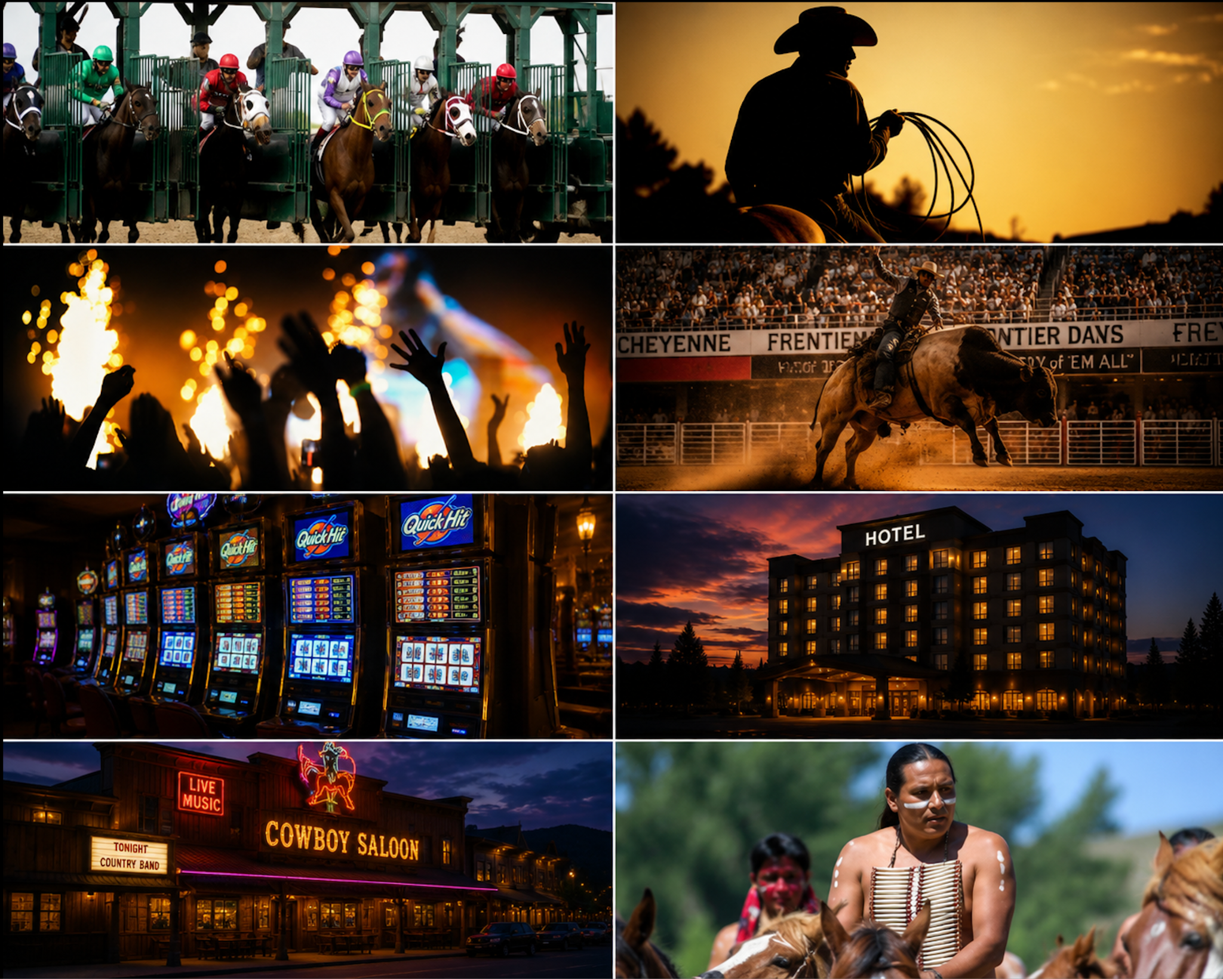
Gateway East & Gateway West – destination entertainment resort overview
THE OFFERING
A Platform for Major Brands. The Stateline land developments are suited for corporations and operators seeking a flagship Western presence, including hospitality and gaming groups, tribal enterprises, sports organizations, entertainment companies, and lifestyle brands.
As one of the most extraordinary destination development opportunities in the American West, these sites are strategically positioned at Wyoming's two busiest gateway borders (one adjoining Colorado and the other Utah), offering exceptional visibility, year-round tourism flow, and long-term commercial potential.
PROPOSAL SUBMISSION AND TIMELINE
Proposal Submission and Review Period: July 1, 2026 through September 30, 2026
Proposals will be reviewed and negotiated on a rolling basis as they are received, and a final decision may be made at any time before the September 30 deadline.
USAGE
Based on market studies (from The Innovation Group and also the Wyoming Gaming Commission by Spectrum Gaming Group – see data room) and extensive research, these are not conceptual developments. They are strategic land assets with schematic master-planned potential to create a new category of Western destination entertainment, including gaming, rodeo stadiums, hotels, restaurants, concert venues, retail villages, museums, RV resorts, truck stops, and large-scale entertainment infrastructure.
Buyers may acquire both properties together or either site individually, with flexible acquisition structures considered.
THE VISION
Designed to establish a new Western destination category, the projects combine sport, culture, hospitality, and year-round entertainment, rooted in Wyoming's global identity as the home of the American West.
The vision is to create two world-class destination resort complexes that position Wyoming as the premier gateway to Western culture, hospitality, and large-format entertainment, establishing a new iconic national destination brand. Significantly, the projects combine the potential for pari-mutuel wagering and global simulcasting.
WHY THIS OPPORTUNITY IS RARE
Two Border Locations with Massive Built-in Traffic. The sites are positioned directly along Interstate 25 in the east and Interstate 80 in the west, major transportation corridors connecting Denver, Fort Collins (3.4 million population), Salt Lake City, Park City (2.6 million population), and more than 3.5 million annual national park visitors.
A Complete Destination Ecosystem. Each site supports the potential for a fully integrated resort program, including rodeo and event stadiums, concert amphitheaters, hotels, pari-mutuel gaming with global simulcasting, restaurants, retail villages, luxury RV resorts, truck and trailer facilities, and museums.
Flexible Acquisition Paths. Bulk buyers may acquire both properties as part of a unified destination strategy or purchase either site independently. Purchasers may also introduce component partners, including gaming, hotel operators, restaurant groups, rodeo organizations, and entertainment operators. Creative transaction structures will be considered.
The seller may also provide vetted proposals from interested operators for gaming, hotels, restaurants, rodeo organizations, and additional resort components.
Proposals Are Invited for Bulk Buyers and Individual Businesses. Businesses including hotel operators, rodeo organizations, truck stop operators, gaming groups, and other entertainment or hospitality concepts are invited to submit proposals for inclusion within the two resort complexes. Qualified proposals may be presented to final buyers.

TERMS & CONDITIONS
For full terms and conditions, contact the seller directly. A data room QR code is provided below for bulk buyers and individual site operators.
Contact: Eric Nelson – (702) 682-8918 – Eric@GatewayRodeo.com
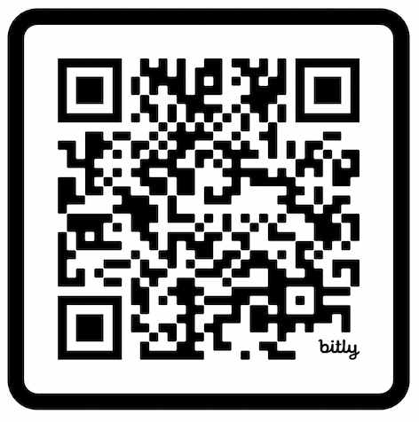
Scan QR code to access the project data room
CONFIDENTIAL — FOR QUALIFIED BUYERS AND INVESTORS ONLY
Disclaimer: See data room package for full terms, market study references, and site details.

